- Course Management System
Requirements
- The system must manage student registration, course enrollment, assignments, and results.
- It should allow faculty to upload materials and monitor student progress.
- The system must be secure, reliable, and available online.
- It should ensure data privacy, quick performance, easy usability, and compatibility with multiple devices.
Functional Requirements :
- Registration
- Course enrollment
- Upload Study materials
- Assignment submission
- Result publishing
Non-Functional requirements :
- Secure Login : Ensure only authorized users can access the system using passwords or OTP.
- System availability : The System should be operational 24/7 without downtime.
- Fast performance : The System should load pages and process requests quickly.
- Data Privacy : Personal and academic details must be kept confidential.
- Scalability : The system should handle increasing number of users smoothly.
- Device compatibility : The system should function on mobiles, tablets, and computers.
Risks
- Server downtime
- Data Privacy risk
- Hacking threats
- Marks alteration risk
- Login failures
- Attendance errors
- Software bugs
- Poor internet connectivity
Risk – Prevention
- Use Secure login credentials
- Update software regularly
- Backup data frequently
- Use strong network security
- Monitor system activity regularly
UML diagrams
Use case diagram
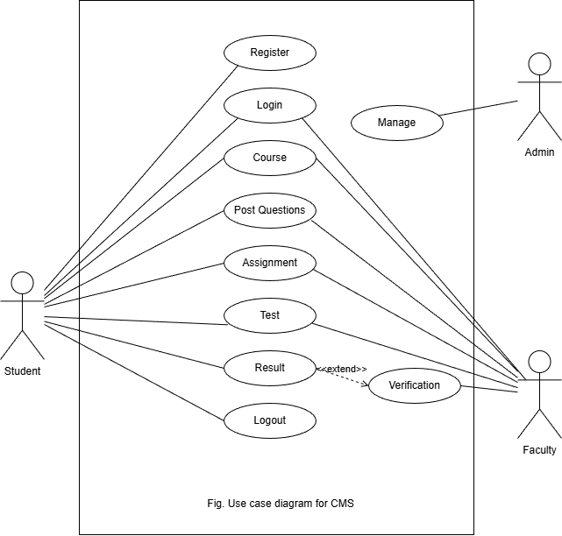
Sequence diagram
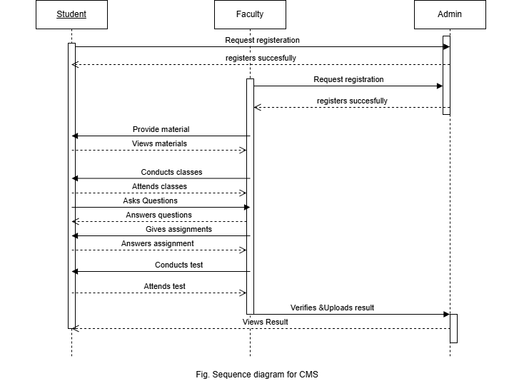
Activity Diagram
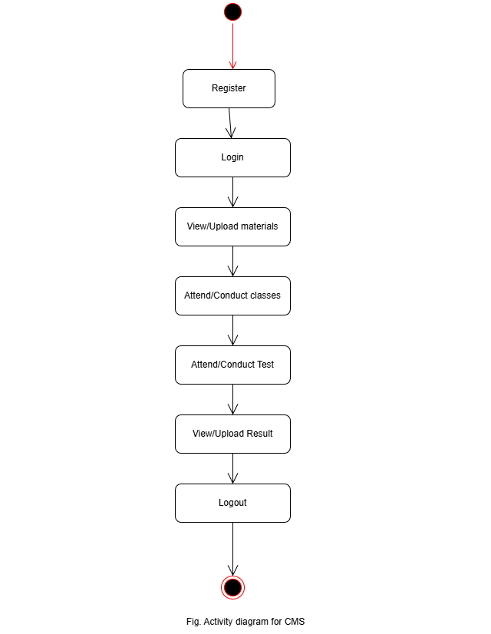
Class Diagram
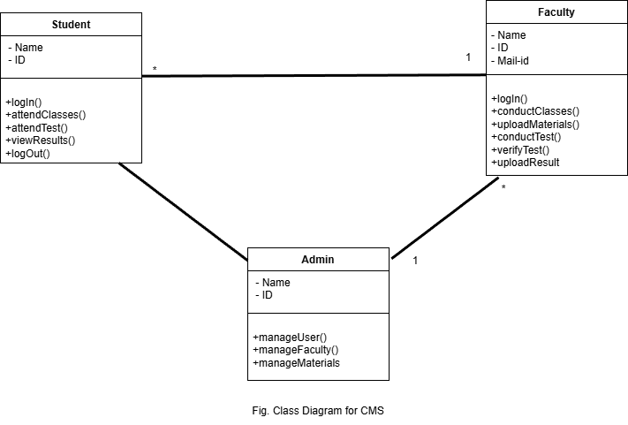
User stories and epics
- Epic 1: Student Management
- US-1 : As a student, I want to register in the system, So that I can enroll courses I require.
- US-2 : As a faculty, I want to register , So that I can teach Students.
- Epic 2: Learning Materials
- US-2 : As a faculty, I want to upload study materials and assignments, So that Students can access them.
- US-3 : As a Student, I want to submit assignments online, So that teachers can check my learning status.
- Epic 3: Test/Exam
- US-4 : As a faculty, I want to take quiz, So that I can check students growth.
- US-5 : As a student, I want to attend test, So that I can get my certification.
- Epic 4: Evaluation
- US-6 : As a faculty, I want to verify the test results, So that I can upload results.
- US-7 : As admin, I want to publish results, So that students can view them.
- Epic 5: Log out
- US-8 : As a student, I want to logout after completion of my course, So that my data is safe.
Test Cases
- Functional requirements
1. Login Test Case
- Input: Valid username & password
- Expected Result: Login successful
2. Invalid Login
- Input: Wrong credentials
- Expected Result: Error message displayed
3. Add Course
- Action: Enter course details
- Expected Result: Course added
4. Enroll Course
- Action: Select course
- Expected Result: Enrollment successful
5. View Courses
- Action: Click view courses
- Expected Result: Course list displayed
6. Update Course
- Action: Modify details
- Expected Result: Changes saved
7. Delete Course
- Action: Delete course
- Expected Result: Course removed
8. Logout
- Action: Click logout
- Expected Result: User logged out
- Non Functional Requirements
1. Performance Test
- Check: Page load time
- Expected Result: Loads within few seconds
2. Security Test
- Check: Unauthorized access
- Expected Result: Access denied
3. Usability Test
- Check: Easy navigation
- Expected Result: User-friendly interface
4. Reliability Test
- Check: System during heavy usage
- Expected Result: Works without failure
5. Compatibility Test
- Check: Different browsers/devices
- Expected Result: Works properly

-------------------------------------***********-------------------------------------

- Zomato
Requirements
- The system must allow users to search restaurants, place orders, make secure payments, and track deliveries.
- It should support ratings, offers, and customer support.
- The application must be fast, secure, reliable, and available 24/7.
- It should handle traffic during peak hours and ensure safe storage of user and payment data with proper privacy protection.

Functional requirements
- Registration/Login
- Search Restaurants
- View menu
- Place/Cancel order
- Online payment
- Order Tracking
- Ratings/reviews
Non-Functional requirements
- Fast response : Ensure quick loading of pages.
- Secure Payment : Protects transaction data.
- 24/7 availability : System work anytime.
- Data privacy : Protects user information.
- Scalability : Handles many users at once.
- User-Friendly : Easy to use interface.
Risk
- Wrong or delayed food delivery.
- Payment gateway.
- Fake restaurant listings.
- Customer data privacy breach.
- Server downtime issues.
- Poor food quality complaints.
- Negative reviews affecting reputation.
- Cyberattacks and financial loss.
Risk – Prevention
- Verify restaurants ratings before ordering.
- Use secure payment methods (UPI/Cards).
- Track orders regularly.
- Report wrong deliveries immediately.
- Keep app updated.
- Avoid sharing OTP/password.
- Use strong account password.
UML diagrams
Use case diagram
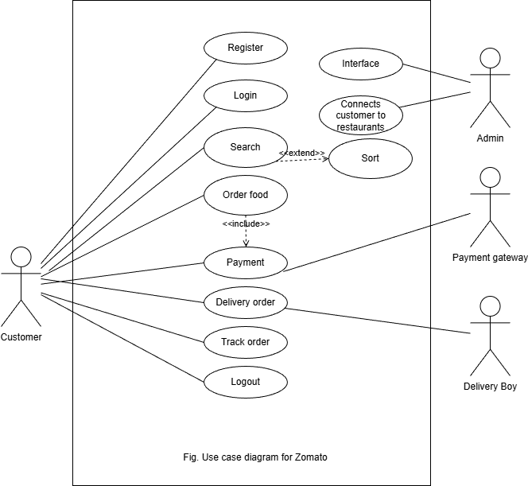

Sequence diagram
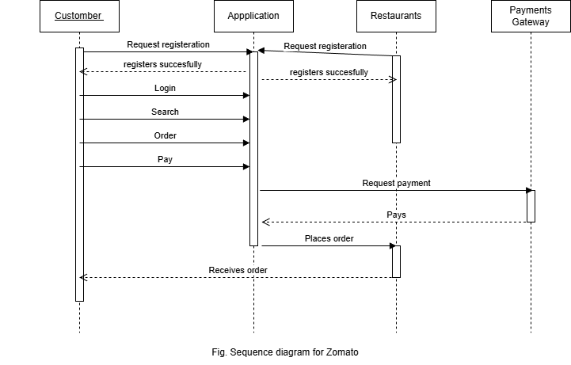

Activity diagram
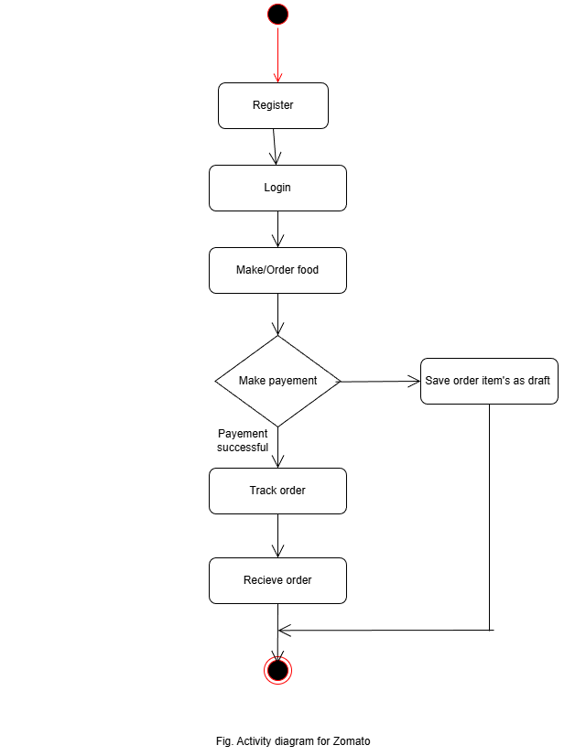

Class diagram
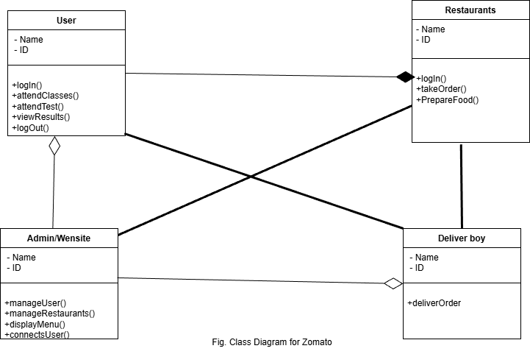

User stories and epics
- Epic 1: User Management
- US-1 : As a user, I want to register in the system, So that I can order food.
- US-2 : As user, I want to update my profile , So that I can choose food.
- Epic 2: Order Management
- US-2 : As a user, I want to search restaurants , So that I can choose food.
- US-3 : As a user, I want to place and track order, So that I know delivery status.
- US-4 : As a restaurant, I want to take orders or be notified so that I can prepare food.
- Epic 3: Payment & Reviews
- US-5 : As a User, I want secure payment, So that my transaction is safe.
- US-5 : As a user, I want to give ratings, So that I can share my feedback .
- Epic 4: Delivery
- As a delivery person, I need to login to the application, So that I can do my work assigned.
- As a delivery person I need to track users location so that I can deliver food.
- Epic 5: Log out
- US-8 : As a user, I want to logout after completion of my order, So that my data is safe.
Test Cases
Functional requirements
1. Login Test Case
- Input: Valid email & password
- Expected Result: User logs in successfully
2. Invalid Login
- Input: Wrong password
- Expected Result: Error message displayed
3. Search Restaurant
- Input: Restaurant name
- Expected Result: Relevant results shown
4. Add to Cart
- Action: Select food item
- Expected Result: Item added to cart
5. Place Order
- Action: Checkout with valid address
- Expected Result: Order placed successfully
6. Payment Test
- Input: Valid payment details
- Expected Result: Payment successful
7. Track Order
- Action: Click “Track Order”
- Expected Result: Live location updates
8. Cancel Order
- Action: Cancel before dispatch
- Expected Result: Order cancelled with refund
9. Logout
- Action: Click logout
- Expected Result: User logged out
10. App Performance
- Check: Load time
- Expected Result: App responds quickly
Non Functional Requirements
1. Performance Test
- Check: Page load time
- Expected Result: Loads within few seconds
2. Security Test
- Check: Unauthorized access
- Expected Result: Access denied
3. Usability Test
- Check: Easy navigation
- Expected Result: User-friendly interface
4. Reliability Test
- Check: System during heavy usage
- Expected Result: Works without failure
5. Compatibility Test
- Check: Different browsers/devices
- Expected Result: Works properly

-------------------------------------***********-------------------------------------
- Library Management System
Requirements
- The system must manage book records, issue and return processes, member details, and fine calculation.
- It should allow easy search and reservation of books.
- The system must be reliable, secure, and user-friendly.
- It should maintain accurate records, provide backup facilities, and generate reports efficiently for administrators.
Functional Requirements :
- Registration
- Book search
- Issue and return books
- Member registration
- Fine calculation
- Book reservation
- Report generation
Non-Functional requirements :
- Secure Login : Ensure only authorized users can access the system using passwords or OTP.
- System availability : The System should be operational 24/7 without downtime.
- Fast performance : The System should load pages and process requests quickly.
- Data Privacy : Personal and academic details must be kept confidential.
- Scalability : The system should handle increasing number of users smoothly.
- Device compatibility : The system should function on mobiles, tablets, and computers.
Risks
- Data loss
- Incorrect book records
- Unauthorized access
- Marks alteration risk
- System crash
- Network failure
- Backup failure
- Report generation errors
- User authentication problems
Risk – Prevention
- Use proper authentication system
- Maintain regular data backups
- Install antivirus software
- Restrict unauthorized access
- Perform system maintenance regularly
UML diagrams
Use case diagram
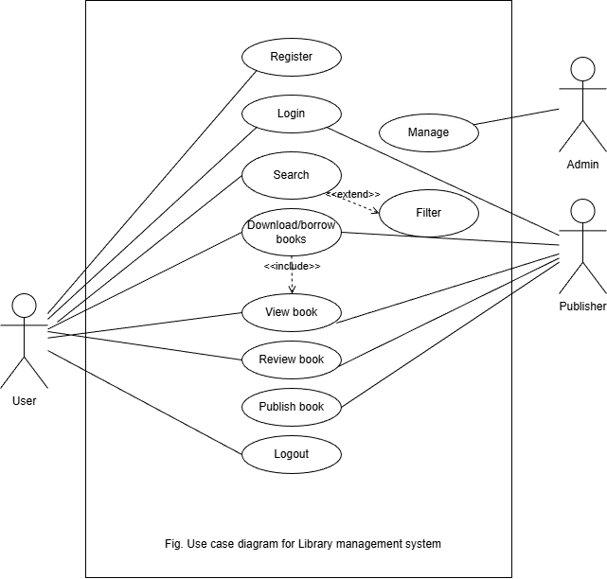
Sequence diagram

Activity Diagram

Class Diagram

User stories and epics
- Epic 1: User account management
- US-1 : As a user, I want to register online, So that I can access digital resources.
- US-2 : As a user, I want secure login so that my account is protected.
- US-3 : As a admin, I want to manage user accounts so that access is controlled.
- Epic 2: Digital Resource Management
- US-4 : As a user, I want to search e-books, So that I access them.
- US-5 : As an author, I want to upload e-books and journals, So that users can access them.
- US-6 : As an admin , I want to categorize digital content, So that it is well organized.
- Epic 3: Access and download
- US-4 : As a faculty, I want to take quiz, So that I can check students growth.
- US-5 : As a student, I want to attend test, So that I can get my certification.
- Epic 4: Evaluation
- US-6 : As a faculty, I want to verify the test results, So that I can upload results.
- US-7 : As admin, I want to publish results, So that students can view them.
- Epic 5: Log out
- US-8 : As a student, I want to logout after completion of my course, So that my data is safe.
Test Cases
- Functional requirements
1.Login Test Case
- Input: Valid username & password
- Expected Result: Login successful
2. Invalid Login
- Input: Wrong credentials
- Expected Result: Error message displayed
3. Add Book
- Action: Enter book details
- Expected Result: Book added successfully
4. Search Book
- Input: Book name/author
- Expected Result: Relevant results displayed
5. Issue Book
- Action: Select book for issue
- Expected Result: Book issued successfully
6. Return Book
- Action: Return issued book
- Expected Result: Book returned and updated
7. Delete Book
- Action: Remove book
- Expected Result: Book deleted
8. View Records
- Action: Check issued/available books
- Expected Result: Records displayed
9. Logout
- Action: Click logout
- Expected Result: User logged out
Non Functional Requirements
1. Performance Test
- Check: Page load time
- Expected Result: Loads within few seconds
2. Security Test
- Check: Unauthorized access
- Expected Result: Access denied
3. Usability Test
- Check: Easy navigation
- Expected Result: User-friendly interface
4. Reliability Test
- Check: System during heavy usage
- Expected Result: Works without failure
5. Compatibility Test
- Check: Different browsers/devices
- Expected Result: Works properly

-------------------------------------***********-------------------------------------

- Online Shopping System
Requirements
- The system must allow users to search Products, place orders, make secure payments, and track deliveries.
- It should support ratings, offers, and customer support.
- The application must be fast, secure, reliable, and available 24/7.
- It should handle traffic during peak hours and ensure safe storage of user and payment data with proper privacy protection.

Functional requirements
- Registration/Login
- Search Product
- View Product
- Place/Cancel order
- Online payment
- Order Tracking
- Ratings/reviews
Non-Functional requirements
- Fast response : Ensure quick loading of pages.
- Secure Payment : Protects transaction data.
- 24/7 availability : System work anytime.
- Data privacy : Protects user information.
- Scalability : Handles many users at once.
- User-Friendly : Easy to use interface.
Risk
- Wrong or delayed product delivery.
- Payment gateway.
- Fake product listings.
- Customer data privacy breach.
- Server downtime issues.
- Poor product quality complaints.
- Negative reviews affecting reputation.
- Cyberattacks and financial loss.
Risk – Prevention
- Verify product ratings before ordering.
- Use secure payment methods (UPI/Cards).
- Track orders regularly.
- Report wrong deliveries immediately.
- Keep app updated.
- Avoid sharing OTP/password.
- Use strong account password.
UML diagrams
Use case diagram
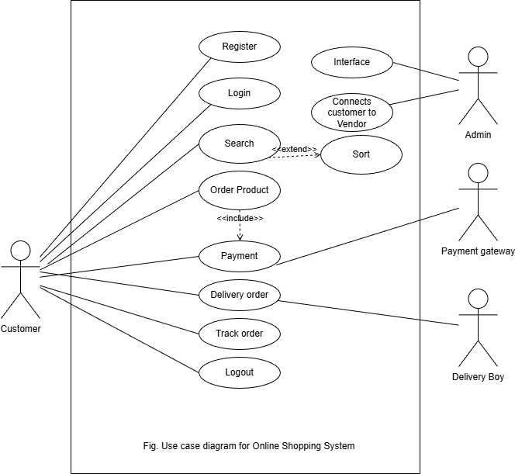

Sequence diagram
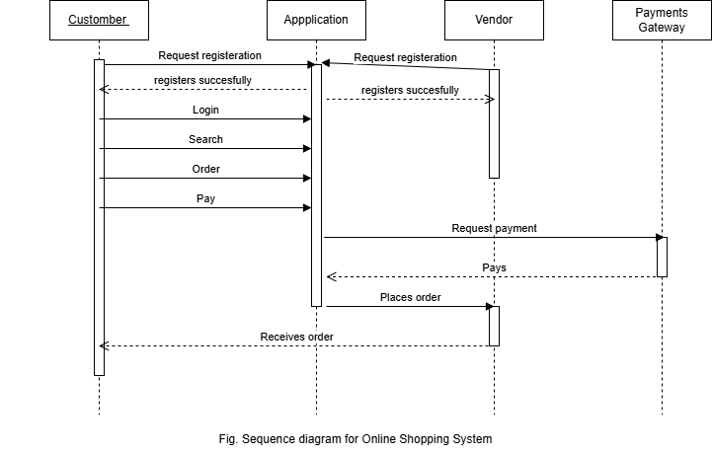

Activity diagram
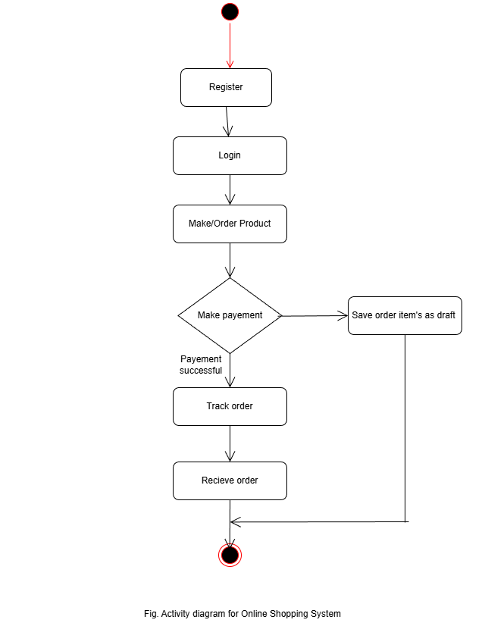

Class diagram
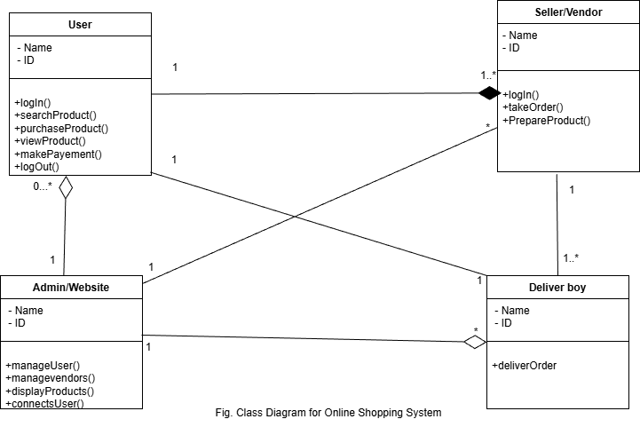

User stories and epics
- Epic 1: User Management
- US-1 : As a user, I want to register in the system, So that I can order product.
- US-2 : As user, I want to update my profile , So that I can choose product.
- Epic 2: Order Management
- US-2 : As a user, I want to search brands , So that I can choose product.
- US-3 : As a user, I want to place and track order, So that I know delivery status.
- US-4 : As a Seller, I want to take orders or be notified so that I can prepare order.
- Epic 3: Payment & Reviews
- US-5 : As a User, I want secure payment, So that my transaction is safe.
- US-5 : As a user, I want to give ratings, So that I can share my feedback .
- Epic 4: Delivery
- As a delivery person, I need to login to the application, So that I can do my work assigned.
- As a delivery person I need to track users location so that I can deliver food.
- Epic 5: Log out
- US-8 : As a user, I want to logout after completion of my order, So that my data is safe.
Test Cases
Functional requirements
- Login Test Case
- Input: Valid email & password
- Expected Result: User logs in successfully
- Invalid Login
- Input: Wrong password
- Expected Result: Error message displayed
- Search Product
- Input: Product name
- Expected Result: Relevant results shown
- Add to Cart
- Action: Select product item
- Expected Result: Item added to cart
- Place Order
- Action: Checkout with valid address
- Expected Result: Order placed successfully
- Payment Test
- Input: Valid payment details
- Expected Result: Payment successful
- Track Order
  - Action: Click “Track Order”
  - Expected Result: Live location updates
8. Cancel Order
- Action: Cancel before dispatch
- Expected Result: Order cancelled with refund
9. Logout
- Action: Click logout Expected Result: User logged out
Non Functional Requirements
1. Performance Test
- Check: Page load time
- Expected Result: Loads within few seconds
2. Security Test
- Check: Unauthorized access
- Expected Result: Access denied
3. Usability Test
- Check: Easy navigation
- Expected Result: User-friendly interface
4. Reliability Test
- Check: System during heavy usage
- Expected Result: Works without failure
5. Compatibility Test
- Check: Different browsers/devices
- Expected Result: Works properly

-------------------------------------***********-------------------------------------

- Online Banking
Requirements
- Online banking system includes functional requirements like user registration, login, balance checking, fund transfer, bill payment, and transaction history.
- Admin manages accounts and security.
- Non-functional requirements include high security, fast performance, reliability, availability, scalability, and user-friendly interface across devices.
Functional requirements
- User registration and login
- Account balance inquiry
- View transaction history
- Fund transfer (within bank and other banks)
- Bill payment and recharge
- Add/Manage beneficiaries
- Password change and profile update
- OTP/2-factor authentication for security
- Download account statements
- Admin can manage users and transactions
Non-Functional requirements
- Fast response : Ensure quick loading of pages.
- Secure Payment : Protects transaction data.
- 24/7 availability : System work anytime.
- Data privacy : Protects user information.
- Scalability : Handles many users at once.
- User-Friendly : Easy to use interface.
Risk
- Security breach
- Transaction failure
- Server downtime
- Data loss
- Unauthorized access
- System errors
- Network issues
Risk – Prevention
- Use strong encryption and authentication
- Provide transaction confirmation and retry
- Use backup servers
- Regular data backup
- Role-based access control
- Regular testing
- Stable network and failover system

UML diagrams
Use case diagram
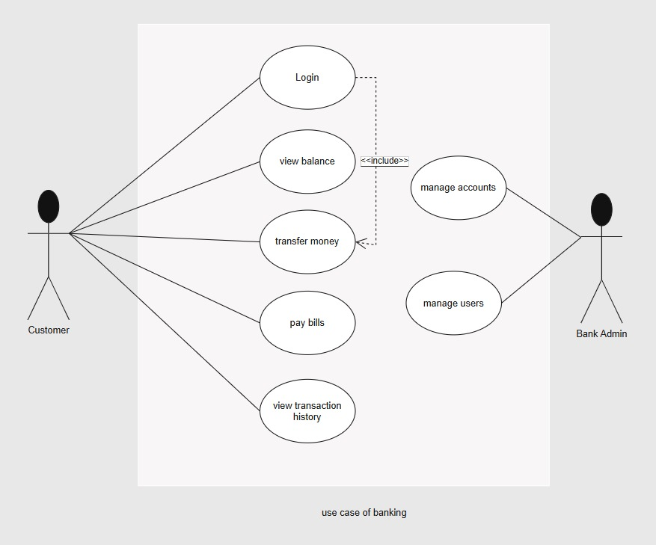

Sequence diagram

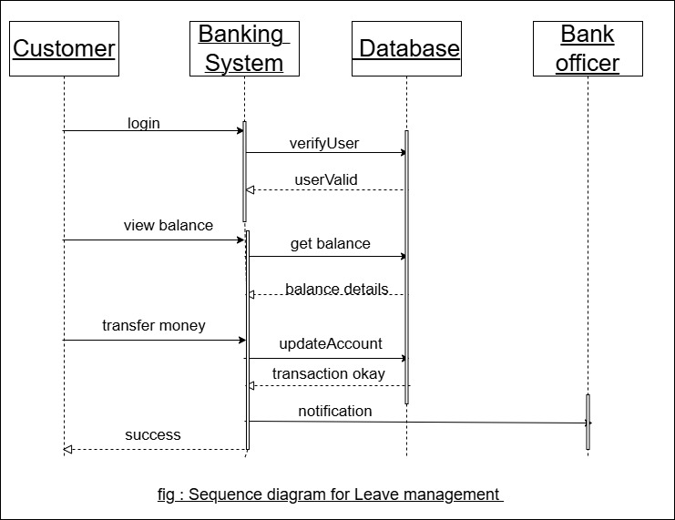
Activity diagram
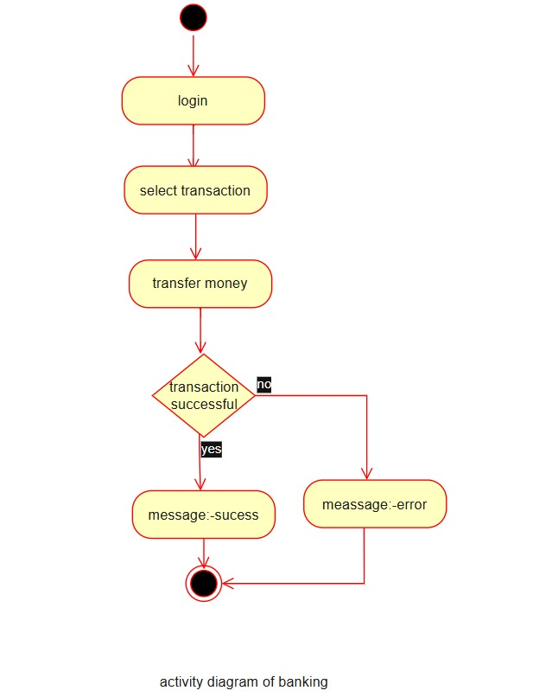

Class diagram
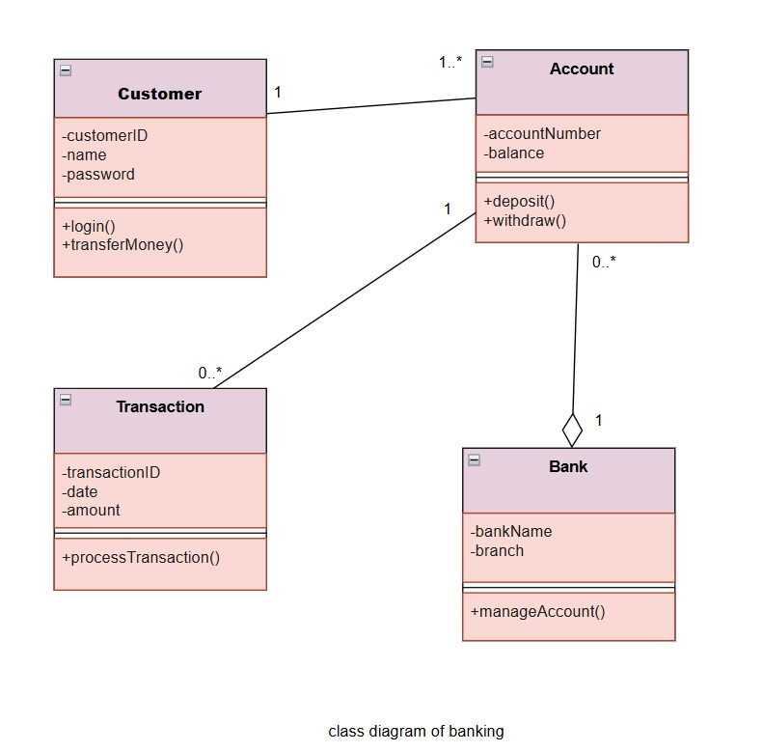

User stories and epics
Epic 1: User Management
- As a user, I want to register so that I can create an account
- As a user, I want to login so that I can access my account
Epic 2: Account Management
- As a user, I want to check balance so that I know my account status
- As a user, I want to view transaction history so that I can track usage
Epic 3: Fund Transfer
- As a user, I want to transfer money so that I can send funds
Epic 4: Bill Payment
- As a user, I want to pay bills online so that I can save time
Epic 5: Security Management
- As a user, I want secure authentication so that my account is safe
Epic 6: Admin Dashboard
- As an admin, I want to manage user accounts so that system runs smoothly
Test Cases
- Functional requirements
1. Search Product
- Input: Product name
- Expected Result: Results displayed
2. Add to Cart
- Action: Select item
- Expected Result: Item added
3. Remove Item
- Action: Remove from cart
- Expected Result: Item removed
4. Place Order
- Action: Checkout
- Expected Result: Order placed
5. Payment Test
- Input: Valid payment
- Expected Result: Payment successful
6. Cancel Order
- Action: Cancel order
- Expected Result: Order cancelled
7. Logout
- Action: Click logout
- Expected Result: Logged out
Non Functional Requirements
1. Performance Test
- Check: Page load time
- Expected Result: Loads within few seconds
2. Security Test
- Check: Unauthorized access
- Expected Result: Access denied
3. Usability Test
- Check: Easy navigation
- Expected Result: User-friendly interface
4. Reliability Test
- Check: System during heavy usage
- Expected Result: Works without failure
5. Compatibility Test
- Check: Different browsers/devices
- Expected Result: Works properly

-------------------------------------***********-------------------------------------

- E-Binnding
Requirements
- E-Binding system includes functions like user registration, login, document upload, binding request, status tracking, and payment.
- Admin manages documents and approvals. Non-functional needs include security, fast performance, reliability, scalability, and user-friendly interface.
Functional requirements
- User registration and login
- Upload documents
- Request binding service
- Track binding status
- Online payment
- Download final bound document
- Profile management
- Admin approval and management
Non-Functional requirements
- Fast response : Ensure quick loading of pages.
- Secure Payment : Protects transaction data.
- 24/7 availability : System work anytime.
- Data privacy : Protects user information.
- Scalability : Handles many users at once.
- User-Friendly : Easy to use interface.
Risk
- Data loss
- Security breach
- Upload failure
- Payment issues
- System downtime
Risk – Prevention
- Regular backups
- Secure authentication
- Stable upload system
- Multiple payment options
- Backup servers

UML diagrams
Use case diagram
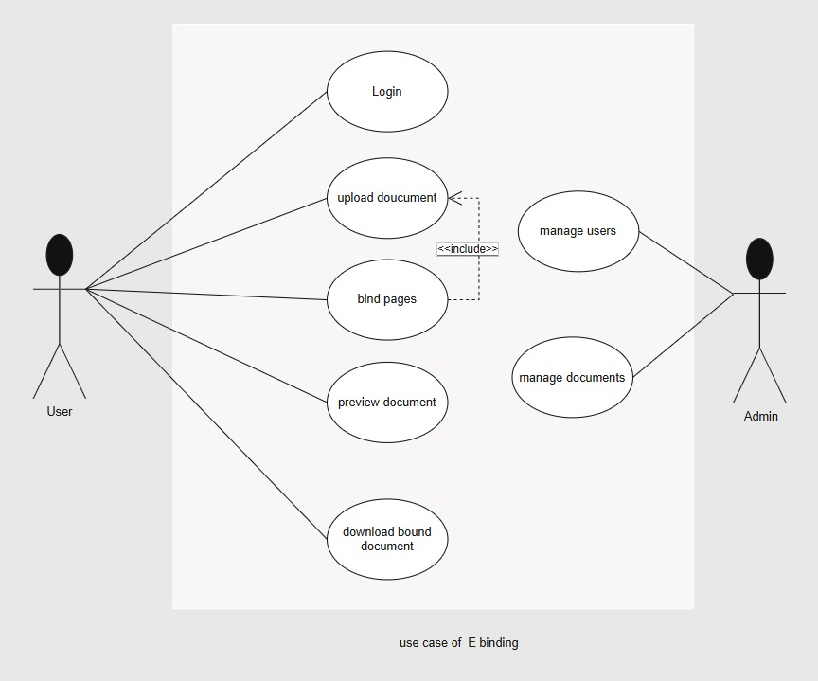

Sequence diagram
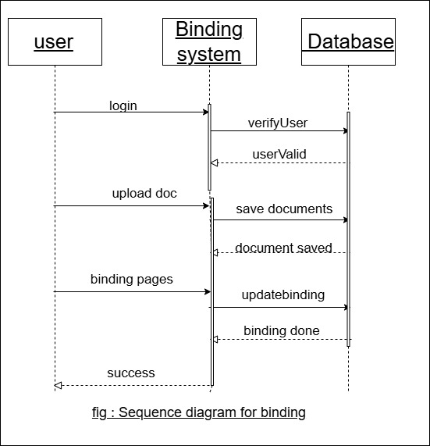

Activity diagram
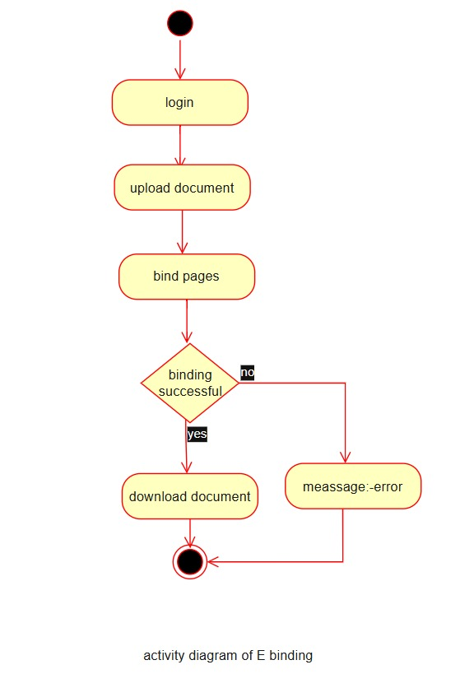

Class diagram
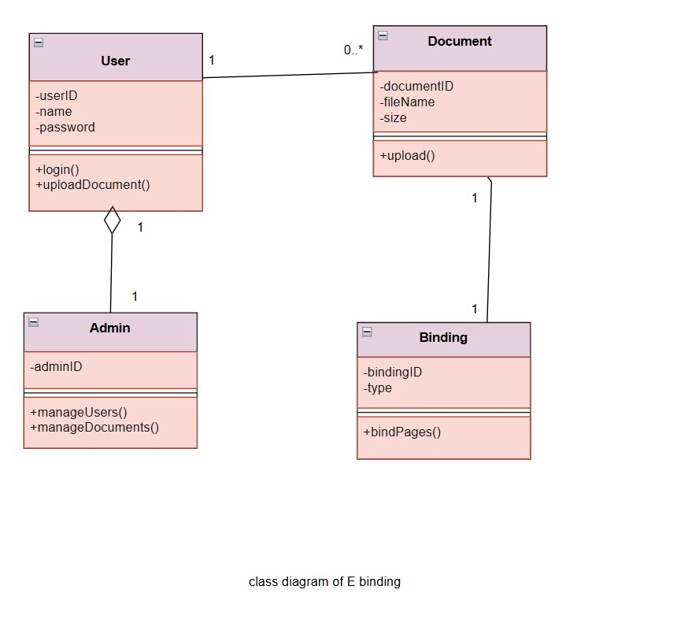

User stories and epics
Epic 1: User Management
- As a user, I want to register/login so that I can access system
Epic 2: Document Management
- As a user, I want to upload documents so that I can request binding
Epic 3: Service Request
- As a user, I want to request binding so that I can get documents processed
Epic 4: Payment System
- As a user, I want to pay online so that service is confirmed
Epic 5: Tracking System
- As a user, I want to track status so that I know progress
Epic 6: Admin Dashboard
- As an admin, I want to manage requests so that workflow is maintained
Test Cases
- Functional requirements
1. Login Test Case
- Input: Valid login
- Expected Result: Login successful
2. Upload Document
- Action: Upload file
- Expected Result: File uploaded
3. Select Binding Type
- Action: Choose type
- Expected Result: Option selected
4. Preview Document
- Action: Click preview
- Expected Result: Preview displayed
5. Place Order
- Action: Confirm order
- Expected Result: Order placed
6. Payment Test
- Input: Valid payment
- Expected Result: Payment successful
7. Logout
- Action: Click logout
- Expected Result: Logged out
Non Functional Requirements
1. Performance Test
- Check: Page load time
- Expected Result: Loads within few seconds
2. Security Test
- Check: Unauthorized access
- Expected Result: Access denied
3. Usability Test
- Check: Easy navigation
- Expected Result: User-friendly interface
4. Reliability Test
- Check: System during heavy usage
- Expected Result: Works without failure
5. Compatibility Test
- Check: Different browsers/devices
- Expected Result: Works properly

-------------------------------------***********-------------------------------------

- Leave Management System
Requirements
- Leave management system includes functions like employee login, leave application, approval/rejection, leave balance tracking, and report generation.
- Admin manages employees and policies. Non-functional needs include security, reliability, performance, scalability, and user-friendly interface.
Functional requirements
- Employee registration and login
- Apply for leave
- Approve/reject leave (manager)
- View leave balance
- Track leave status
- Leave history and reports
- Profile management
• Admin manages users and policiesNon-Functional requirements
- Fast response : Ensure quick loading of pages.
- Secure Payment : Protects transaction data.
- 24/7 availability : System work anytime.
- Data privacy : Protects user information.
- Scalability : Handles many users at once.
- User-Friendly : Easy to use interface.
Risk
- Data loss
- Unauthorized access
- System errors
- Server downtime
- Incorrect leave calculation
Risk – Prevention
- Regular backups
- Secure authentication
- Regular testing
- Backup servers
- Accurate validation and logic checks

UML diagrams
Use case diagram
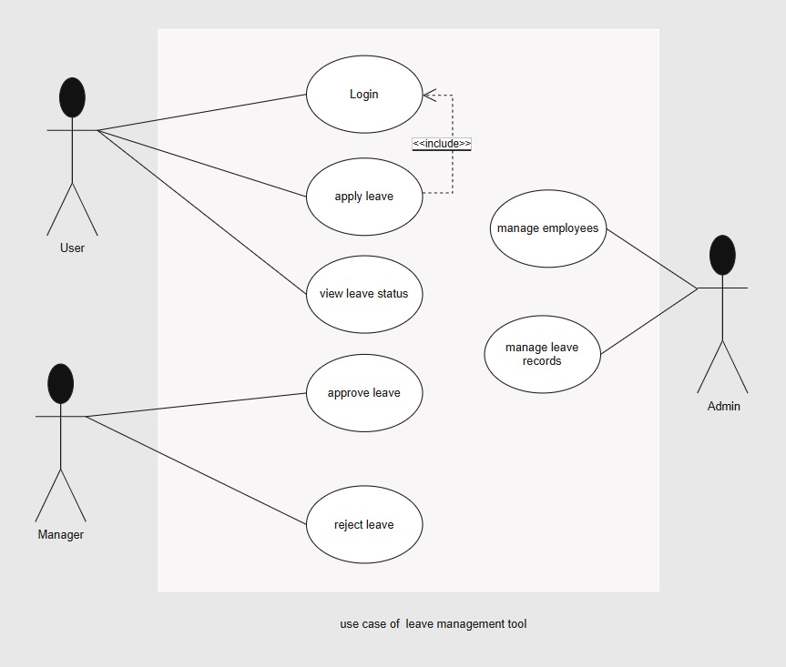

Sequence diagram
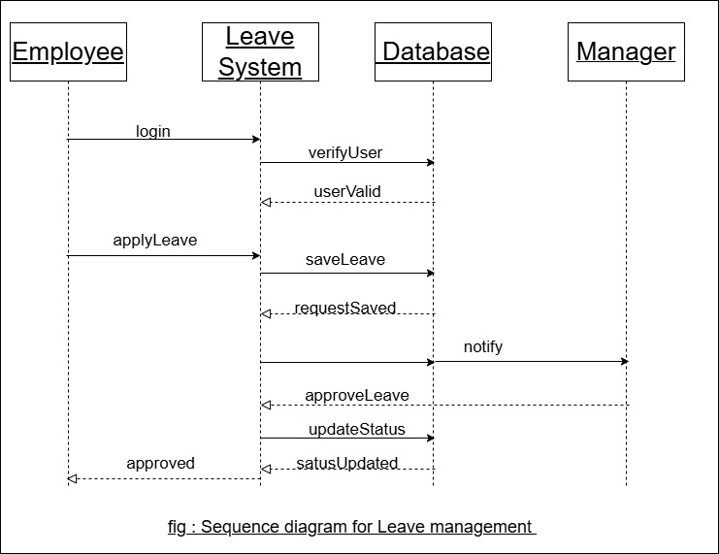

Activity diagram
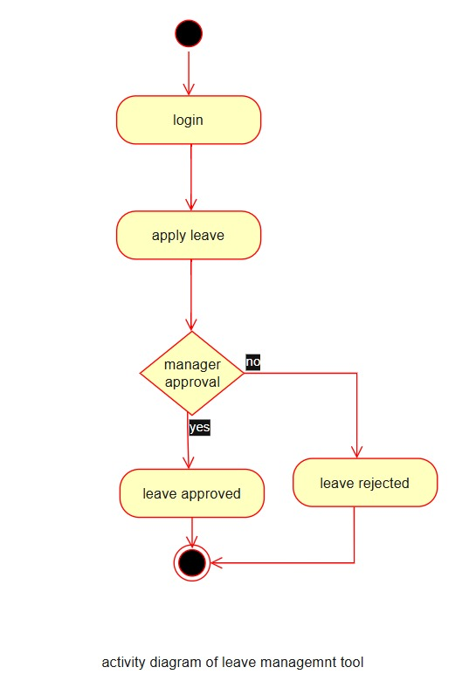

Class diagram
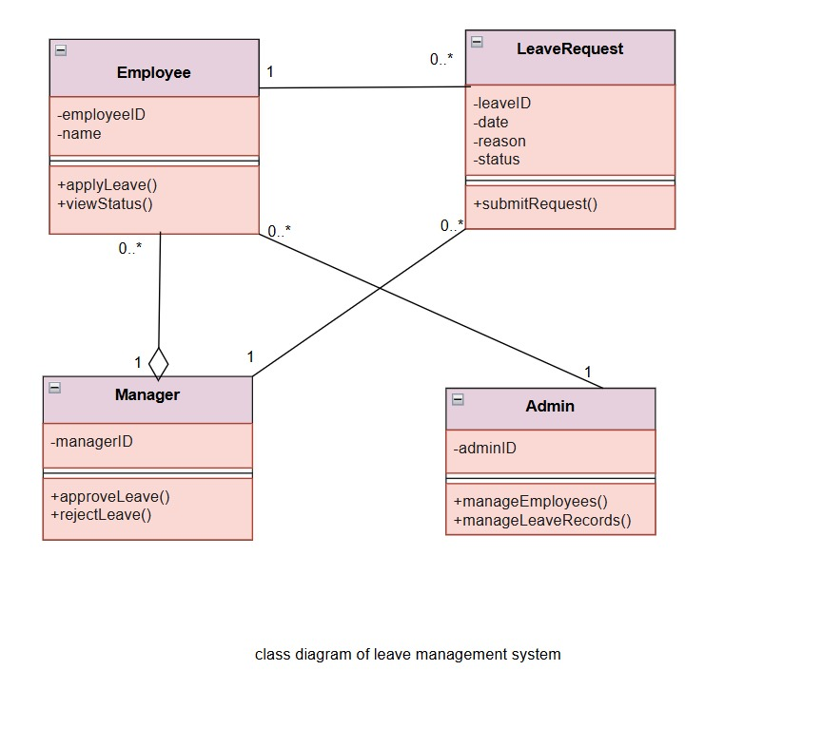

User stories and epics
Epic 1: User Management
- As an employee, I want to login so that I can access system
Epic 2: Leave Application
- As an employee, I want to apply for leave so that I can request time off
Epic 3: Leave Approval
- As a manager, I want to approve/reject leave so that I can manage team availability
Epic 4: Leave Tracking
- As an employee, I want to track leave status so that I know approval progress
Epic 5: Reports Management
- As a user, I want to view leave history so that I can track records
Epic 6: Admin Dashboard
- As an admin, I want to manage employees and policies so that system runs smoothly
Test Cases
- Functional requirements
Login Test Case
- Input: Valid credentials
- Expected Result: Login successful
2. Apply Leave
- Input: Valid dates & reason
- Expected Result: Leave submitted
3. Invalid Leave
- Input: Wrong dates
- Expected Result: Error shown
4. Approve/Reject Leave
- Action: Manager action
- Expected Result: Status updated
5. View Leave Status
- Action: Check status
- Expected Result: Details displayed
6. Cancel Leave
- Action: Cancel request
- Expected Result: Leave cancelled
7. Logout
- Action: Click logout
- Expected Result: Logged out

Non Functional Requirements
1. Performance Test
- Check: Page load time
- Expected Result: Loads within few seconds
2. Security Test
- Check: Unauthorized access
- Expected Result: Access denied
3. Usability Test
- Check: Easy navigation
- Expected Result: User-friendly interface
4. Reliability Test
- Check: System during heavy usage
- Expected Result: Works without failure
5. Compatibility Test
- Check: Different browsers/devices
- Expected Result: Works properly

-------------------------------------***********-------------------------------------

